6. The Everspring Inn Mass Evictions & Systemic Failures in Seattle’s Tenant Protections

A City-Sanctioned Humanitarian Crisis
In August 2020, during one of the most devastating public health crises in modern history, dozens of residents at the Everspring Inn (8201 Aurora Ave N, Seattle) were forcibly and unlawfully evicted, despite the Seattle eviction moratorium, which explicitly prohibited such actions.

These were not tenants with financial safety nets. They were the sick, the elderly, the disabled, and the working poor, surviving month to month in a rundown motel that had functioned as long-term housing. They were thrown onto the streets with nowhere to go, in the middle of a global pandemic.

This was not just an eviction. It was a state-enabled act of cruelty.

The mass eviction took place shortly after the Seattle Police Department (SPD) issued a Chronic Nuisance Property Declaration against the property’s owner, Myung Ha Kang (Ryan Kang), citing ongoing criminal activity at the motel. Instead of addressing these concerns, Kang weaponized this declaration, lied to tenants, and falsely claimed the City of Seattle itself was evicting them.

Chronology of Complaints & SDCI’s Failures

August 18, 2020 – A Day of Forced Displacement
On August 18, 2020, at least 13 emergency complaints were filed with SDCI, reporting:

- Tenants being forcibly locked out of their rooms.
- Windows boarded up to prevent reentry.
- Water and electricity shut off.
- Armed security guards intimidating and physically removing residents.

Despite the urgency and severity, SDCI immediately marked all complaints as “Admin Closure” or “Voluntary Compliance”labeling them as “JCEO” (Just Cause Evictions “COVID-19-X” with no further action taken.

Key Complaints Filed (All Marked ‘Admin Closure’):
- Complaint #007155-20CP – Reports of a mass eviction in progress, water shut off, windows boarded up, and armed security deployed. SDCI closed the complaint the same day with no investigation.
- Complaint #007945-20CP – Tenants reported being locked out, belongings trapped inside, and forced into the streets. SDCI closed it without action.
- Complaint #007177-20CP – A tenant documented over a year of residency at the motel, provided rental receipts, mail evidence, and proof of long-term habitation—clearly establishing legal tenant rights under Seattle law. SDCI closed the case immediately.
- Complaint #007948-20CP – Reports of exit doors being blocked, windows boarded, and physical intimidation by security personnel. SDCI closed without investigation.
- Complaint #007949-20CP – A sick tenant reported being trapped inside the property with no hot water, afraid to leave because of COVID-19 exposure. SDCI did nothing.

This was not a bureaucratic oversight. It was a deliberate choice to ignore clear violations of Seattle’s Just Cause Eviction Ordinance and the eviction moratorium.

Discrepancies Between SDCI’s Statements & Reality

SDCI’s Claim: "We were not aware of the evictions."
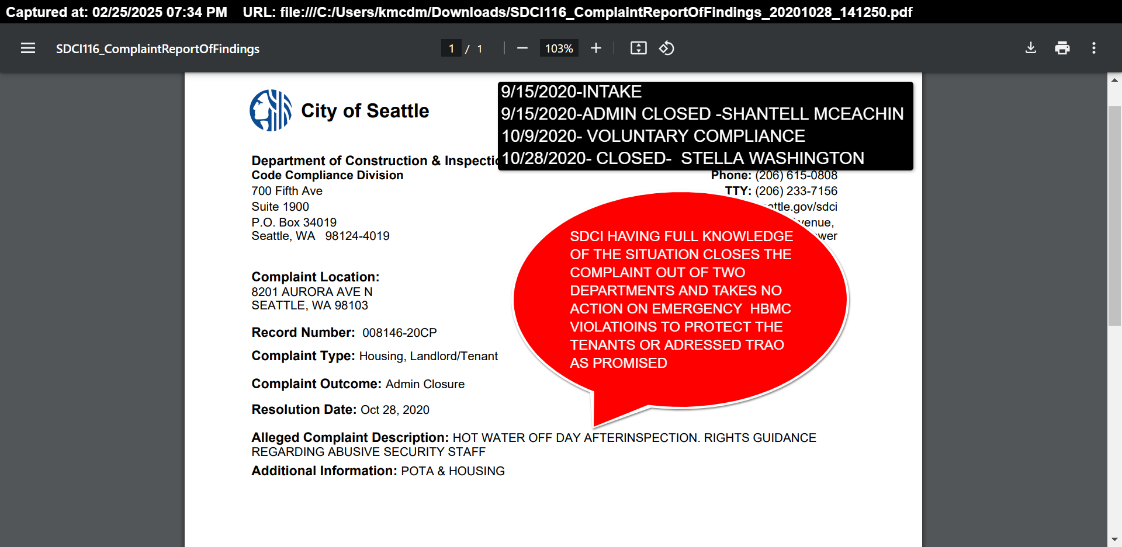
Contradiction:

- Evidence shows multiple complaints were filed on August 18, 2020, explicitly stating that evictions were in progress.
- Complaint #007155-20CP clearly reported the landlord hiring security to prevent tenants from entering, shutting off water, and boarding up windows.
- Despite this, SDCI immediately marked the complaint as ‘Admin Closure’—proving they were aware and chose not to act.

SDCI’s Claim: "The evictions were justified under the nuisance property declaration."
Contradiction:

- The Chronic Nuisance Declaration issued to Ryan Kang in July 2020 did not authorize evictions. It demanded the owner correct issues or face city enforcement.
- Instead, Kang misrepresented the declaration, falsely telling tenants the City was evicting them, and SDCI allowed this lie to go unchecked.
- At no point did SDCI or SPD issue legal eviction notices as required by law.

SDCI’s Claim: "There were safety concerns that required immediate action."
Contradiction:

- If safety was a concern, SDCI should have intervened with inspections and habitability enforcement before the evictions, not ignored tenant reports.
- SDCI’s own records show that they were aware of severe habitability violations but failed to act for years.
- Allowing an illegal eviction did not resolve the safety issues—it left residents in even more dangerous conditions, exposed to homelessness during a pandemic.

SDCI’s Systemic Failures & Violations

1. Violation of Seattle & Washington State Eviction Moratoriums
- At the time, Seattle and Washington State had an eviction ban in place, prohibiting landlords from removing tenants due to nonpayment of rent or lease expiration.
- Exceptions required a court order, yet Ryan Kang did not obtain one.
- SDCI was responsible for enforcing these protections but refused to act.

2. Pattern of Negligence & Non-Enforcement
- Tenant complaints had been filed about Everspring Inn documenting habitability violations, unsafe conditions, and failure to meet minimum rental standards.
- SDCI failed to enforce compliance, Only issuing a

3. Conflict of Interest & Permitting Irregularities
- Despite knowing about severe habitability issues, SDCI later approved construction permits allowing the motel to convert into a hotel.
- This raises questions about regulatory bias and whether SDCI prioritized business interests over tenant protections.

4. Misuse of Public Funds & RRIO Non-Compliance
- King County allocated funding for rapid rehousing at motels like Everspring.
- Under SMC 22.214 (Rental Registration and Inspection Ordinance, RRIO), properties used for long-term housing (30+ days) must meet rental habitability standards.
- SDCI did not enforce RRIO compliance, allowing public funds to be used on substandard, unsafe housing.
Harrell, with REACH, said she was especially appalled to learn, from a story in the Seattle Times, that Kang had received at least $164,000 in “rapid rehousing” assistance from the city of Seattle in 2018, making him the single largest beneficiary of the program. Rapid rehousing is supposed to provide temporary assistance to get people into safe, stable housing—typically in market-rate apartments—until they can pay the full rent themselves. Rent for a room at the Everspring ranged from $1,800 to $2,400 a month, and it was far from safe or stable.
“If the city is paying for something like that, then how come no one checked to make sure things were running properly?” Harrell said. “It’s not fair that he got all this money and didn’t run it the way it should have behttps://publicola.com/2020/08/25/tenants-describe-worsening-conditions-at-aurora-motel-as-owner-signs-agreement-with-spd/en run.”

The Human Toll: Lives Discarded, Forgotten, and Unprotected
🚨 Where did these tenants go?
🚨 Who among them survived the pandemic?
🚨 How many of them died alone, unhoused, because of this eviction?

The reality is, we don’t know. There were no follow-ups, no support services deployed, no tracking of displaced individuals.

These were people already on the brink of survival—the sick, the elderly, the disabled, the working poor. The City of Seattle abandoned them to die.

This Is Why the Seattle Tenant-Landlord Compliance Authority (STLCA) Must Exist
🔹 SDCI must be stripped of its power over tenant protections.
🔹 The Seattle Tenant-Landlord Compliance Authority (STLCA) must take over enforcement.
🔹 We need real oversight, real accountability, and real protection for tenants.

This is not just policy reform. It is about ending government-sanctioned human rights violations.

🔴 Seattle must decide: protect tenants or continue enabling corruption. 🔴

This pattern of dismissal mirrors Everspring, where SDCI’s inaction allowed violations to fester. Case Study: Everspring Inn—A Pandemic Betrayal Background: Owned by Myung Ha Kang, Everspring Inn (8201 Aurora Ave N) was declared a chronic nuisance by the Seattle Police Chief in July 2020, giving Kang 15 days to respond. Instead, on August 1, 2020, Kang initiated a mass eviction during the COVID-19 pandemic, using armed security, boarded windows, and threats of police arrests. Complaints: On August 18, 2020, tenants filed #007155-20CP (mass eviction in progress), #007945-20CP (locked out, doors boarded), and #007163-20CP (unlawful eviction), reporting water shutoffs and intimidation. SDCI marked these "Admin Closure" and "Voluntary Compliance" the same day, with no investigation, violating eviction moratoriums. Historical Neglect: Complaints since 2013, a 2021 NOV with over 150 violations, and unregistered RRIO status persisted, yet construction permits were issued in 2021 to convert it into a hotel. Impact: Thirteen tenants, including one with a sick partner, were displaced, facing heightened health risks. Evidence Dismissed: A Pattern of Neglect SDCI’s response is inadequate: 18 Lowell Emerson records note “No Inspection” (e.g., 2023-01-06), and all 108 lack “LastInspDate,” confirming transparency gaps. Everspring’s immediate closures amplify this failure, endangering tenants during a crisis. Eviction Moratorium Violations (Everspring Hotel case) Background – COVID-19 Protections: During the COVID-19 pandemic, Seattle and Washington State enacted eviction moratoriums to protect tenants from displacement. Landlords were prohibited from evicting tenants except for extraordinary circumstances (and even then, tena nts had added protections). Despite these rules, a mass eviction occurred at the Everspring Inn, a low-income Aurora Avenue motel, in August 2020 – right in the middle of the moratorium. This incident showcases multiple systemic failures: a landlord exploiting loopholes, siloed city agencies, and SDCI’s inadequate response to an illegal eviction of dozens of vulnerable tenants.

Everspring Mass Eviction: In early August 2020, approximately 25 long-term residents of the Everspring Inn (many who had lived there for years) found notices taped to their doors stating they must vacate immediately (Tenants Describe Worsening Conditions at Aurora Motel as Owner Signs Agreement with SPD - PubliCola). The motel owner, Ryan Kang, cited crime problems and a pending agreement with police as justification for the sudden clear-out. These notices were not legal eviction papers – they provided no advance notice, no court process, and no offer of relocation assistance (T In effect, Kang illegally evicted all tenants overnight, in blatant violation of the eviction moratorium and Seattle’s Just Cause Eviction Ordinance. Tenants recalled being told to leave on the spot; some had their cars towed and utilities shut off (hot water was turned off) as pressure to force them ou). Many of these residents were low-income and had nowhere to go – they ended up homeless, living in cars or shelters after being kicked out. One tenant, seven months pregnant at the time, fell ill and was hospitalized, attributing it to the stress and moldy conditions at the motel. Others described the panic and confusion of being expelled without recourse: “They didn’t offer us any resources, nothing. They just told us we had to be out that day… It should have been done the legal way.”nder any normal circumstances, this would be an unlawful mass eviction; during a pandemic moratorium, it was especially egregious.

City’s Role and SDCI’s Response: How did SDCI and other authorities respond? Initially, Seattle Police (SPD) played a controversial role. The owner contacted SPD, claiming the motel was a “chronic nuisance” property due to crime on-site, and sought an abatement agreement. Five days after Kang’s DIY eviction notices, SPD’s chief signed an official nuisance abatement agreement with the owner – essentially retroactively blessing the clearance of tenants as a solution to the crime issues Kang then used that SPD agreement as post-facto cover for what he’d already done . It’s important to note that even if a property is declared a nuisance, nothing in the law allows a landlord to summarily evict tenants without due process ( Proper procedure would have been to relocate tenants with assistance and then shut down the building, but that didn’t happen. SPD’s involvement muddled the situation: the presence of police (Kang’s notice warned that police would do a “walkthrough” to ensure everyone left intimidated tenants, even though SPD later claimed they never actually conducted an enforcement action that day . Essentially, SPD’s agreement was used as a pretext to bypass tenant protections.

SDCI, for its part, was absent on the ground. Tenants and outreach workers noted that no SDCI officials came to the motel during the evictions. SDCI’s Code Compliance division is responsible for enforcing the Just Cause Eviction Ordinance (JCEO) – which was clearly violated – yet in real time the department did not intervene. Only after media coverage and legal aid groups sounded the alarm did SDCI respond, and that was largely on paper. SDCI spokesperson Bryan Stevens said the department was “reviewing 16 complaints” filed by Everspring tenants about the illegal evictions). He indicated that if the owner attempted formal evictions through the courts, SDCI would then issue a Notice of Violation for breaking the JCEO (i.e. evicting without just cause) . However, because Kang never went to court – he simply threw people out – this enforcement mechanism had no effect. In other words, SDCI took a reactive stance (waiting for an official eviction filing to trigger enforcement) while tenants were already being thrown on the street. Tenant advocates found this response wholly inadequate: by the time any NOV could be issued, the damage was done and tenants were displaced. Indeed, Stevens acknowledged that the evictions were all “de facto and informal,” making it hard for the city to hold the owner accountable through the usual process ( This bureaucratic shrug – essentially “our hands are tied because it wasn’t a formal eviction” – exemplifies the failure to protect tenants when it counted most.
“Wendy Shark, a spokesperson for the Seattle Department of Construction and Inspections, said the city is "monitoring the situation at the Everspring Inn," as well as the efforts to rehouse its residents. Whether or not each resident was technically a "tenant" is determined on a "case-by-case analysis," she said. If a resident has stayed in a hotel or motel for more than 30 days, that unit is regulated under the city's housing codes for rental properties, she said. AUGUST 18TH 2020”About the Authors & Contributors

David Kroman
David Kroman is formerly a reporter at Crosscut, where he covered city politics.

Lisa Etter Carlson, co-founder and director of women’s health initiatives at the Aurora Commons, a nonprofit that helps sex workers and people experiencing homelessness in the neighborhood, said she was surprised when media coverage didn’t jostle the city of Seattle into action. “I kind of assumed that surely, with all the press, with the absurdity and inhumanity of turning these precious people out during a pandemic, during an eviction moratorium, surely someone out there was doing something,” she said. “And it just became clear that no no one was. They never called. They never showed up. We never received any assistance.”
Bryan Stevens, a spokesman for the city’s Department of Construction and Inspections, says SDCI is reviewing 16 complaints from Everspring residents—complaints that those residents could use as a defense against a formal eviction proceeding. At that point, the city would also begin issuing notices to the property owner, Kang, for violating the city’s just-cause eviction ordinance. Since the evictions have all been de facto and informal, it’s hard to see how this option is meaningful to the current and former tenants.
And, as Etter Carlson noted, no one from the city has showed up to inspect the site or stop the evictions from happening. For the past week and a half, the only city employees who’ve been consistently on site are members of the Human Services Department’s Navigation Team, bearing offers of shelter—a significant step down from even a crappy motel room, and one that many tenants aren’t willing to consider.
“It’s really challenging when people have had their own apartment for years to then, just all of a sudden, pick up and move to a tiny house or a shelter situation,” Etter Carlson said. “It’s not dignifying.”
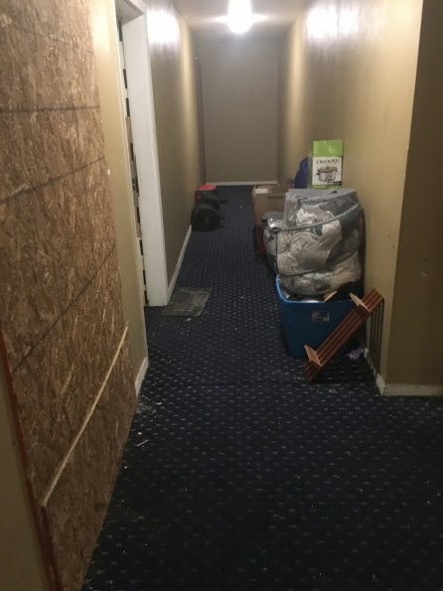
Most of the people at the Everspring had nowhere to go; and so, many of them are still there. As of last weekend, nearly a dozen rooms in the Everspring were still occupied, with plywood sheets sitting just outside their doors as a reminder that if they leave their rooms, they will be considered unoccupied, and the security guards will board up their doors with all their possessions inside. As a result, tenants said, they have taken to sitting in each others’ rooms when one of them leaves so that their doors don’t get boarded up while they’re gone.
“Stevens, from SDCI, says the department got assurances that Kang was only boarding up “unoccupied” rooms. He added that the city has no authority to order a property owner to open up rooms that are boarded up if no one is living there.” LIES AUGUST 20TH 2020By Erica C. BarnettPUBLICOLAhttps://publicola.com/2020/08/25/tenants-describe-worsening-conditions-at-aurora-motel-as-owner-signs-agreement-with-spd/

Aftermath and Denials: The Everspring incident drew outrage from the community and housing advocates. The Public Defender Association and other legal groups intervened to assist tenants, arguing that the nuisance process was misused and did not override tenant rights Under pressure, the City eventually acknowledged the situation was mishandled. SPD faced criticism for what Police Chief Carmen Best later admitted was an error in judgment signing the agreement after learning tenants had been forced out illegally . For SDCI, the episode was a black eye. Although SDCI did later issue an NOV or citation to the owner for violating the eviction moratorium/Just Cause law, officials also downplayed their own responsibility, implying that because this was framed as a police nuisance matter, it was out of SDCI’s purview. In reality, enforcing renters’ rights is exactly SDCI’s job, and the JCEO has no exception for nuisance abatement without due process. City records and testimony indicated a lack of coordination – SDCI and SPD weren’t on the same page, and tenants fell through the cracks as a result. Ultimately, many of the Everspring residents never received justice or restitution (some were owed relocation assistance by law). The case highlights how SDCI’s enforcement of emergency tenant protections failed: a mass eviction slipped through under the guise of “just cause” (nuisance), and SDCI’s stance amounted to rubber-stamping it as justified after the fact. Advocacy organizations point to Everspring as a cautionary tale that tenant protections are only as strong as the agency enforcing them. In this case, SDCI’s inaction effectively nullified the eviction moratorium for those 25 households.

Councilmember Morales’ concern about staff cuts hindering tenant protection is evident here.

